Simulation and Comparative Performance Evaluation of Zigbee, 6LoWPAN and NB-IoT Communication Protocols for IoE Applications using NS-3

Objective:
To simulate and compare Zigbee, 6LoWPAN, and NB-IoT communication protocols using Python in Google Colab by analyzing throughput, end-to-end delay, packet delivery ratio (PDR), and energy consumption through comparative tables and graphs.
Procedure:
- Open Google Colab and create a new notebook.
- Import the required Python libraries: NumPy, Pandas, and Matplotlib.
- Define the simulation parameters, including the number of nodes, packet size, and simulation duration.
- Simulate packet transmission and reception for Zigbee, 6LoWPAN, and NB-IoT.
- Calculate throughput, delay, PDR, and energy consumption for each protocol.
- Display the comparative output table containing all performance metrics.
- Generate graphs for throughput, delay, PDR, energy consumption, and normalized performance.
- Compare the results and identify the suitability of each protocol for different IoE applications.
Program:
import numpy as np
import pandas as pd
import matplotlib.pyplot as plt

# 1. Simulation parameters
np.random.seed(42)
protocols = ["Zigbee", "6LoWPAN", "NB-IoT"]
packets_sent = 3000
payload_bytes = 100
simulation_time = 60 # seconds

# Illustrative assumptions: success probability, delay (ms), energy (mJ/packet)
success_prob = [0.94, 0.96, 0.985]
base_delay = [35, 45, 180]
energy_per_packet = [0.18, 0.24, 0.75]

# 2. Simulate packet delivery and calculate metrics
rows = []

for i, protocol in enumerate(protocols):
received = np.random.binomial(packets_sent, success_prob[i])
pdr = received / packets_sent * 100

throughput = received * payload_bytes * 8 / simulation_time / 1000

delays = np.random.lognormal(
mean=np.log(base_delay[i]) - 0.25**2 / 2,
sigma=0.25,
size=received
)
avg_delay = np.mean(delays)

total_energy = packets_sent * energy_per_packet[i]
energy_delivered = total_energy / received

rows.append([
protocol, packets_sent, received, throughput,
avg_delay, pdr, total_energy, energy_delivered
])

df = pd.DataFrame(rows, columns=[
"Protocol", "Packets Sent", "Packets Received",
"Throughput (kbps)", "Delay (ms)", "PDR (%)",
"Total Energy (mJ)", "Energy/Delivered Packet (mJ)"
])

# 3. Display results table
print("COMPARATIVE IoE PROTOCOL PERFORMANCE")
display(df.round(3))

# 4. Generate four individual performance graphs
graphs = [
("Throughput (kbps)", "Throughput Comparison", "Throughput (kbps)"),
("Delay (ms)", "End-to-End Delay Comparison", "Delay (ms)"),
("PDR (%)", "Packet Delivery Ratio Comparison", "PDR (%)"),
("Energy/Delivered Packet (mJ)",
"Energy Consumption Comparison", "Energy (mJ/packet)")
]

for column, title, ylabel in graphs:
plt.figure(figsize=(8, 5))
bars = plt.bar(df["Protocol"], df[column])
plt.title(title)
plt.xlabel("Communication Protocol")
plt.ylabel(ylabel)
plt.grid(axis="y", linestyle="--", alpha=0.4)

for bar in bars:
value = bar.get_height()
plt.text(
bar.get_x() + bar.get_width()/2,
value,
f"{value:.2f}",
ha="center", va="bottom"
)

plt.tight_layout()
plt.show()

# 5. Normalized performance comparison
# Higher score = better; delay and energy are inverted.
scores = pd.DataFrame({"Protocol": protocols})

for col in ["Throughput (kbps)", "PDR (%)"]:
v = df[col]
scores[col] = (v - v.min()) / (v.max() - v.min() + 1e-12) * 100

for col in ["Delay (ms)", "Energy/Delivered Packet (mJ)"]:
v = df[col]
scores[col] = (v.max() - v) / (v.max() - v.min() + 1e-12) * 100

scores_plot = scores.set_index("Protocol")
scores_plot.plot(kind="bar", figsize=(10, 5))
plt.title("Normalized Performance Comparison")
plt.ylabel("Normalized Score (0–100; higher is better)")
plt.xlabel("Communication Protocol")
plt.xticks(rotation=0)
plt.grid(axis="y", linestyle="--", alpha=0.4)
plt.legend(title="Performance Metric")
plt.tight_layout()
plt.show()

# 6. Save results for the lab record
df.to_csv("IoE_Protocol_Results.csv", index=False)
print("SUCCESS: All 5 graphs and the results table have been generated.")
print("CSV saved as IoE_Protocol_Results.csv")

OUTPUT:
Throughtput Comparsion :
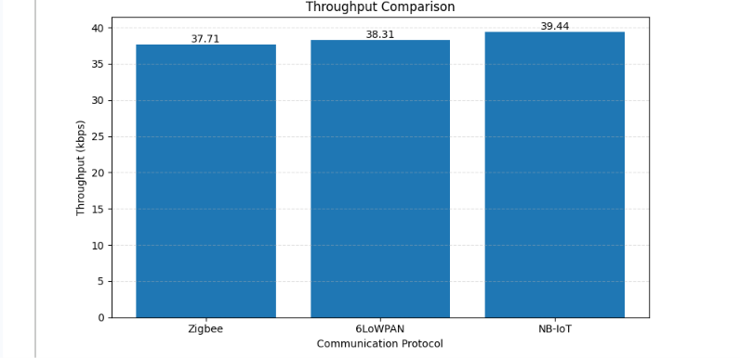

End -to -End Delay:
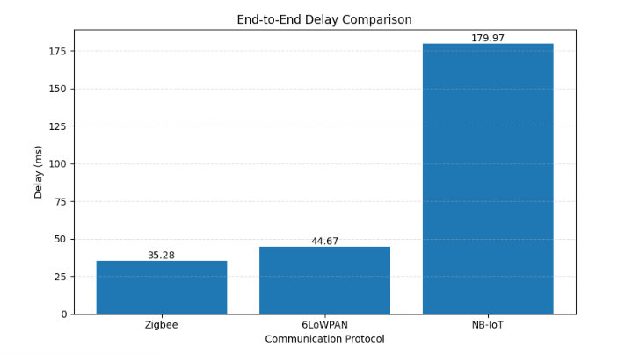
Packet Delivery Ratio Comparison:
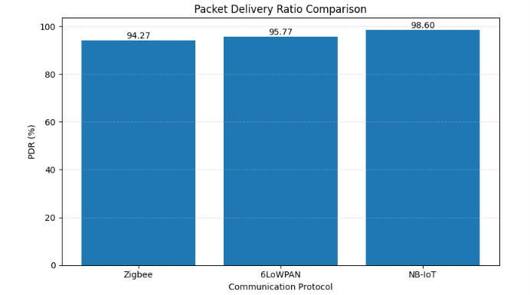

Energy Consumption Comparison:
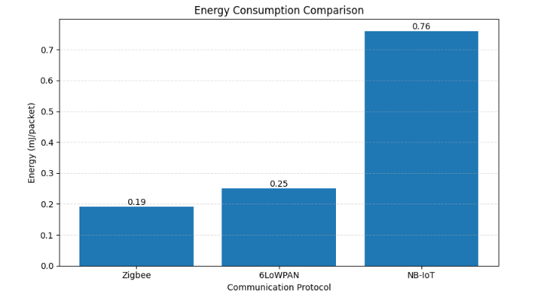
Normalized performance comparison :
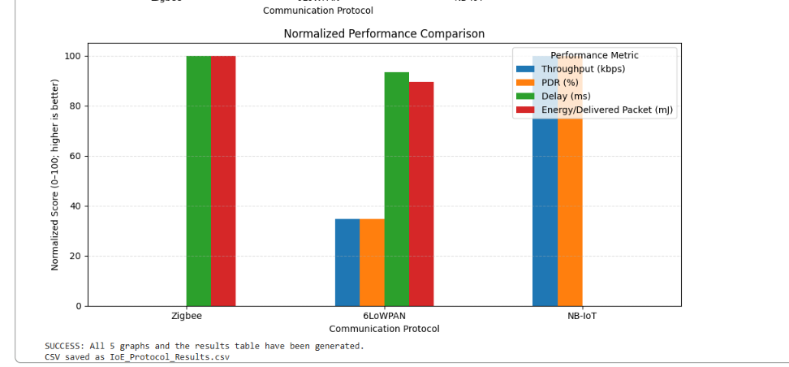

Table Analysis :
PROTOCOL | Zigbee | 6LoWPAN | NB-IOT
Packets sent | 3000 | 3000 | 3000
Packets received | 2828 | 2873 | 2958
Throughput (kbps) | 37.707 | 38.307 | 39.440
Delay( ms ) | 35.280 | 44.671 | 179.972
PDR ( % ) | 94.267 | 95.767 | 98.600
Total energy ( m ) | 540.0 | 720.0 | 2250.0
Energy/delivered packet ( m ) | 0.191 | 0.251 | 0.761
Result:
The Zigbee, 6LoWPAN, and NB-IoT protocols were simulated using Python in Google Colab. Their performance was compared based on throughput, end-to-end delay, packet delivery ratio (PDR), and energy consumption using tables and graphs. The results were analyzed to identify the suitability of each protocol for IoE applications.

